Handcrafted Eco Interiors
Lindsey Eldredge-Fox
SAB622

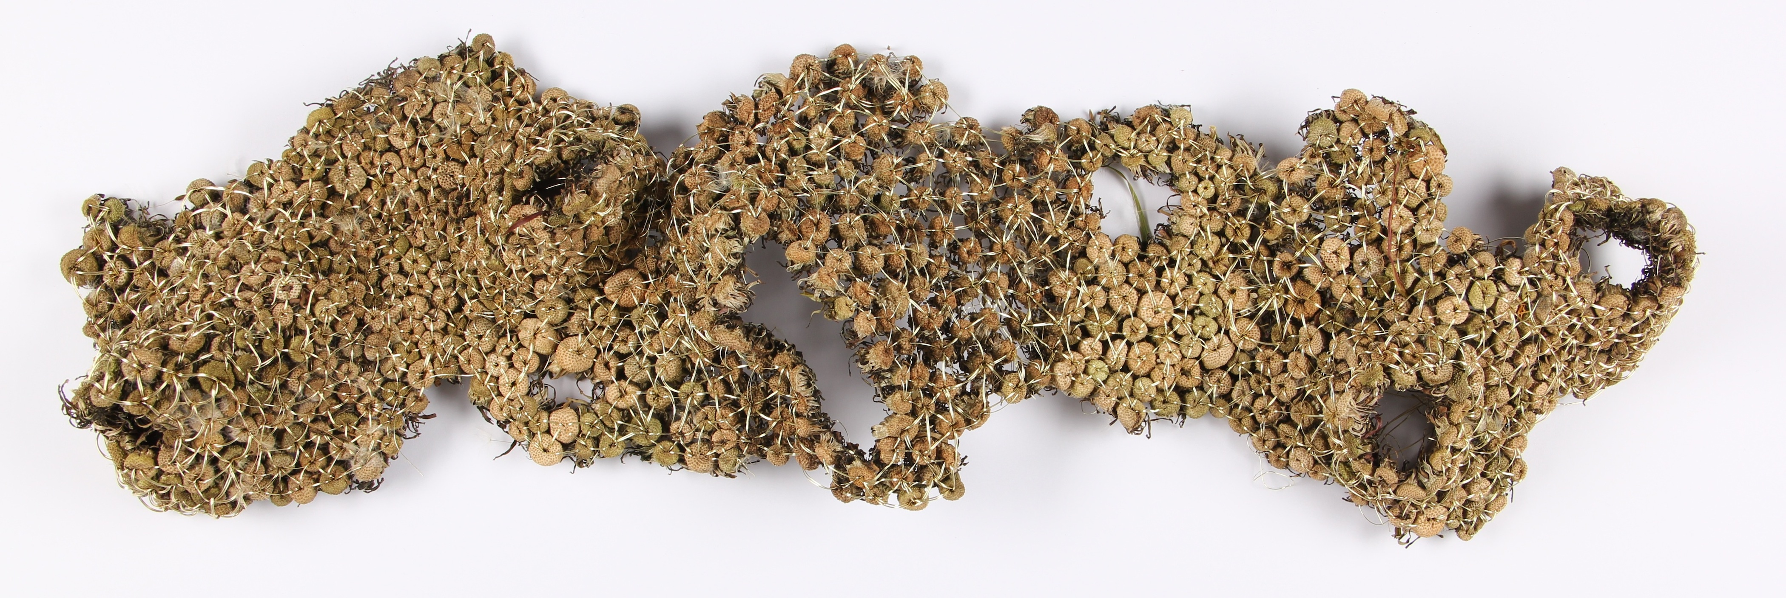

Green space is a huge concept emerging right now in the field of interiors and design. Either through grass roofs that eat up a buildings carbon footprint or through the mere simplicity of building a ‘green wall’ in a home, plants are finding their way into interiors. Moss walls are being constructed within houses creating a green yet decorative and designed outcome. Through my research of these ‘green’ embellishments of the home I began to think about bringing plants into the home in an artistic way.
For this brief I chose to explore a truly sustainable product and process. In the beginning of my explorations and expiramentations, I was sewing plants together merely due to their ability to create an interesting surface. As I developed more reseach involving visiting natural history museums, identifying plants online, and exploring of the native plant life, I began to see a way to make the choice of what plant I was using more significant. In natural history museums and botanical gardens some plants are kept safe, cared for, collected, reveared, and researched. They have been assigned a value by humans purely based on our relationship to them. This made me start to think about what plants we don’t aknoledge or value.
The dandelion for starters is the gardeners pest. We weed it, cut thousands of them down with a lawn mower on a daily basis, and curse its hideous figure after the yellow flowers are gone. Even the yellow flowers scream the fact that you have not speant the time to truly take care of your greenery. By collecting these worthless weeds and sewing them into an intricate surface I hope to add value to the pestering weed. Throughout this process I continued to explore what it means to add value to something through process.
There are many other plants that could be considered in this way and many uses to which they could be put. For now however I seek to explore the concepts of embellishment, decoration, lace, and repitition and the way which they can be used to add value to these seemingly useless and underappreciated materials.

